
PB-T2/IP-CAK/1221/B 7-APR-2022
PRE-BOARD EXAMINATION 3 – TERM II (2021-22)
Subject: Informatics practices  Grade: XII |  | Max. Marks: 35  Time: 70 Minutes
SECTION A
 | a) Which of the following device send data to every connected node:  Ans (ii) Hub |  | 1
 | b) Which out of the following, will you use to have an audio chat with an expert sitting in a far- away place to fix up a technical issue?  - VoIP |  | 1
 | a)What is the significance of cookies stored on a computer?  Ans  A cookie is a small piece of data stored on the user's computer by the web browser while browsing a website. Cookies were designed to be a reliable mechanism for websites to remember stateful information or to record the user's browsing activity. They can also be used to remember pieces of information that the user previously entered into form fields, such as names, addresses, passwords, and payment card numbers.  Cookies can keep you signed in.  Cookies can remember your site preferences.  Cookies can give you locally relevant content. |  | 1
 | b) How is it easier to diagnose fault in Star topology than in Bus topology ?  Ans  It is easier to diagnose fault in star topology because in it, each node is directs connected to central node. And hence, that node which is faulty will stop working and rest can continue processing. While in bus topology if 1 node stops working then it affects the whole system. |  | 1
3. | Write the output  i) SELECT POWER(-2,3); Ans -8  ii) SELECT MOD(10,7); Ans 3  or  Differentiate between single row functions and multiple row functions with example.  Ans  Single Row functions - Single row functions are the one who work on single row and return one output per row. For example, length and case conversion functions are single row functions. Multiple Row functions - Multiple row functions work upon group of rows and return one result for the complete set of rows. They are also known as Group Functions. |  | 2
6. | Write the sql command to perform the following:  - Display the name of current month.  Ans: select monthname(now());  - Display the day of week on which your birthday will fall or fell in 2022.  Ans: select dayname('2022-02-26'); |  | 2
7. | Differentiate between group by and order by clause in sql  Ans:Order by is an SQL clause specified with a SELECT statement to return a result set with the rows being sorted according to a specific order, whereas Group by is an SQL clause specified with the SELECT statement to retrieve data, grouped according to one or more columns. |  | 2
8. | Explain the purpose of Modem and Gateway  Modems are used for data transfer from one computer network to another computer network through telephone lines. The computer network works in digital mode, while analog technology is used for carrying massages across phone lines.  The main purpose of Gateway is that in case if two systems do not share routing protocols, it takes a gateway to get them together. The purpose of Gateways is to translate all protocols on one network into the protocols on another |  | 2
9 | Write SQL query to create a table “Book” with the following structure  Table: Book  Field name Datatype Size Constraint  Book_Id Integer 2 Primary Key  BName Varchar 20 Not Null  Category Varchar 10  Issue_Dt Date  Ans  Create table book(book_id int primary key,  Bname varchar(20) not null,  Category varchar(10),  Issue_dt date); |  | 2
 | SECTION B
6 | Consider the below mentioned table of Electronics,  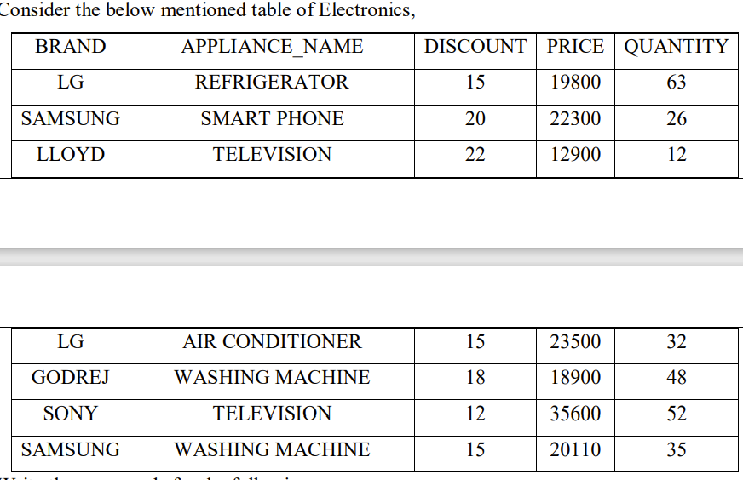  Write the commands for the following:  - Display the average discount of each brand.  Select brand,avg(discount) from electronics group by brand;  - Count the total number of washing machines available in the table.  Select count(*) from electronics where appliance_name=’washing machine’;  - Display the Brand and Name of Appliance with maximum price.  Select brand, appliance_name, max(price) from electronics; |  | 3
7 | - While creating the table Emp(T-id,Tname,salary,dept) last week, Ms. Sharma forgot to include the column course_attended. Now write a command to insert the course_attended column with VARCHAR data type and 30 size into the Emptable? (1)  Alter table emp add course_attended varchar(30);  - Ms Sharma forgot to add a primary key while creating the emp table. Write the query to set T_id as the primary key.(1)  Alter table emp add primary key(T_id);  - Write the command to increase salary of all teachers by 10%. (1)  Update emp set salary=salary+0.1*salary; |  | 3
8 | Consider an EMP table(Empid, Firstname, lastname). Write the query for each of the following.  - Display LastName and Firstname from emp table who have "in" in the second or third position in their first names  Select Firstname, lastname from emp where instr(firstname,’in’)=2 or instr(firstname,’in’)=3;  - Display the Firstname from emp table that are 5 chars long.  Select firstname from emp where length(firstname)=5;  - Display the 2 letters of firstname starting from third character.  Select mid(firstname,3,2) from emp; |  | 3
 | Section C
1. | Consider the following table.  Loan_accounts  Write MySQL commands for the following  - Display the IntRate of all the loans started in 2018.  Select intrate from loan where startdate like ‘2018%’;  - Display the details of all the loans whose rate of interest is not NULL.  Select * from loan where intrate is not null;  - Display the largest loan amount for each loan type.  Select Type,max(loanamount) from loan group by type;  - Display names of female customers.  Select right(cust_name,2) from loan where cust_name like ‘Ms%’; |  | 4
  AcNo | Cust_name | Loanamount | IntRate | StartDate | Type
  1 | Mr.R.K.Gupta | 300000 | 12.00 | 2019-07-19 | HouseLoan
  2 | Mr.S.P.Sharma | 500000 | 10.00 | 2018-03-22 | VehicleLoan
  3 | Ms.K.P.Jain | 300000 | NULL | 2022-03-08 | HouseLoan
  4 | Mr.M.P.Yadav | 800000 | 10.00 | 2018-12-06 | HouseLoan
  5 | Mr.S.P.Sinha | 200000 | 12.50 | 2020-01-03 | VehicleLoan
  6 | Mr.P.Sharma | 700000 | 12.50 | 2018-06-05 | HouseLoan
  7 | Ms.Shanu | 500000 | NULL | 2016-03-05 | GoldLoan
2 | Consider a table SALESMAN with the following data:  Write SQL queries using SQL functions to perform the following operations:  - Display salesman name and bonus after rounding off to two decimal places.  Select sname,round(bonus,2) from salesman  - Display the position of occurrence of the string “Sh” in salesman names.  Select sname,instr(sname,’Sh’) from salesman;  - Display the first two characters from salesman and last two chars.  Select left(sname,2),right(sname,2) from salesman;  d) Display the name of salesman who joined on Monday or Tuesday.  Select sname from salesman where dayname(DOJ)=’Monday’ or dayname(DOJ)=’Tuesday’; |  | 4
  SNO | SNAME | SALARY | BONUS | DATEOFJOIN
  A01 | Beena Mehta | 30000 | 45.235 | 29-10-2019
  A02 | K.L.Sahay | 50000 | 25.348 | 13-03-2018
  B03 | Nisha Thakkar | 30000 | 35.789 | 18-03-2017
  B04 | Leela Yadav | 80000 | NULL | 31-12-2018
  C05 | Gautam Gola | 20000 | NULL | 23-01-1989
  D07 | Neena Sharma | 50000 | 27.894 | 18-03-1999
3 | Ayurveda Training Educational Institute is setting up its centre in Hyderabad with four specialised departments for Orthopedics, Neurology and Pediatrics along with an administrative office in separate buildings. The physical distances between these department buildings and the number of computers to be installed in these departments and administrative office as given as follows. You as a network expert have to answer the queries as raised by them in (i) to (v).  Shortest distances between various locations in metres :  Number of Computers installed at various locations are as follows :  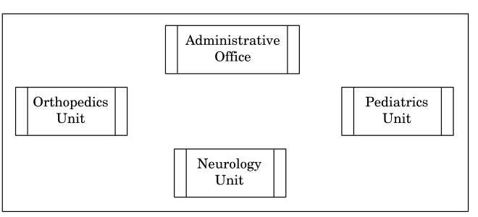  - Suggest a suitable layout for Networking the computer of all wings  - Name the wing where the server is to be installed. Justify your answer.  - Suggest the devices to be installed in each of these buildings for connecting computers installed within the building out of the following:  ● Gateway  ● Modem  ● Switch  iv) Write the name of the type of network out of the following, which will be formed by connecting all the computer systems across the network .  Ans  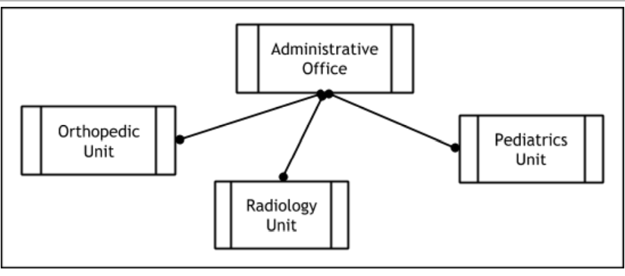  - Administrative Office  - Switch  - LAN |  | 4
  Administrative Office to Orthopedics Unit | 55
  Neurology Unit to Administrative Office | 30
  Orthopedics Unit to Neurology Unit | 70
  Pediatrics Unit to Neurology Unit | 50
  Pediatrics Unit to Administrative Office | 40
  Pediatrics Unit to Orthopedics Unit | 110
  Pediatrics Unit | 40
  Administrative Office | 140
  Neurology | 50
  Orthopedics Unit 80 | 80

